**Shri. Shivaji Education Society, Amravati**

**Dr. Panjabrao Deshmukh Polytechnic, Amravati.**



**Micro Project Report**

**Programming in C [312303]**



**Branch:** Computer Engineering

**Semester:** II

**Academic Session: 2024-25**

**Group Details:**

**Title of the Micro Project: ATM System**

**GROUP MEMBERS**

|  |  |  |
| --- | --- | --- |
| **Sr.No.** | **Name of the student** | **Roll No.** |
| 1 | Aman Sheikh | 57 |
| 2 | Shivansh Tandekar | 04 |
| 3 | Inshaal Qazi | 56 |
| 4 | Sarthak Sapkal | 48 |
| 5 | Sarthak Ambore | 43 |



**Certificate**

This is to certify that,

Roll. No. 57 Mr. Aman Javed Sheikh .

Roll. No. 04 Mr. Shivansh Mahesh Tandekar .

Roll. No. 56 Mr. Inshaal Aatif Qazi .

Roll. No 48 Mr. Sarthak Bharat Sapkal .

Roll. No 43 Mr. Sarthak Narendra Ambore .

of Second semester of Diploma in Computer Engineering of Institute Dr. Panjabrao Deshmukh Polytechnic, Amravati (0024) has completed the Micro Project satisfactorily in subject Programming in C [312303] for the academic year 2024-2025 as prescribed in curriculum.

**Date :** **Place :** Amravati

**Subject Teacher Head of Department**

**INDEX .**

|  |  |  |
| --- | --- | --- |
| **Sr. No.** | **Content** | **Page No.** |
| **1** | Introduction | 5 |
| **2** | Objective | 5 |
| **3** | Program Description | 6 |
| **4** | Code Explanation | 7 |
| **5** | Sample Output and Code | 11 |
| **6** | Conclusion | 12 |
| **7** | Tools Used | 12 |
| **8** | References | 13 |

**1. Introduction:**

The purpose of this micro project is to design and implement a simple ATM (Automated Teller Machine) simulator using the C programming language. This program demonstrates basic banking operations such as checking account balance, depositing money, withdrawing money, and exiting the system. It also includes a PIN verification system to ensure security. The project aims to enhance understanding of fundamental C programming concepts such as variables, loops, conditionals, and user input handling.

**2. Objective:**

1. To create a user-friendly **ATM** simulation program.
2. To implement PIN-based authentication with a limited number of attempts.
3. To allow user to perform basic banking transactions like deposit and withdrawal.
4. To apply and showcase knowledge of C Programming constructs
5. Develop Error–handling mechanisms to address invalid inputs. (e.g., incorrect PIN, Negative amounts.)
6. Create a **user–friendly**, menu driven interface for easy navigation and interface.
7. Ensure Program is adaptable for future enhancement like adding new features or options.
8. Explore efficient use of control structures (e.g., while loops, if-else) to manage program flow
9. Build confidence in developing interactive, console-based applications using C language
10. Document the code for better code’s functionality clearly for better understanding and future reference.

**3. Program Description:**

The ATM simulator program begins with a PIN verification process. The user must enter the correct **PIN is hardcoded as 1245** within three attempts. If all attempts fail, the program terminates with an error massage simulating a security lockout.

Upon successful authentication, a menu-driven interface allows the user to:

1. Check their account balance.

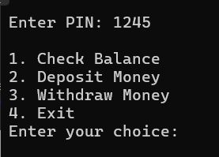

2. Deposit money into the account.

3. Withdraw money from the account.

4. Exit the system.

The initial balance is set to **$1870.0**, and the program ensures that withdrawals do not exceed the available balance. Invalid inputs (e.g., negative amounts or incorrect menu choices) are handled with appropriate error messages.

The design emphasizes simplicity and interactivity, making is accessible for educational purposes while still reflecting **core ATM functionalities**.

* **The Program’s structure is sequential – starting with the Authentication , followed by an infinite loop for menu – yet it incorporates nested conditional statements to manage user input and transaction logic effectively.**

**4. Code Explanation :**

**Below is the breakdown of the key components of the program:**

**4.1 Header and variable Declaration:**

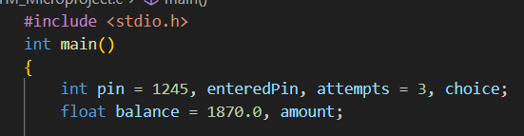

* **#include <stdio.h> :**
* Includes the standard input-output library for functions like printf and scanf.
* **Variables:**
* Pin : Stores the correct PIN (1245).
* enteredPin : Stores the user-entered PIN.
* Attempts : Tracks remaining PIN attempts (initialized to 3).
* Choice : Stores the user’s menu selection.
* Balance : Stores the account balance (initialized to 1870.0).
* Amount : Stores the deposit or withdrawal amount.

**4.2. PIN Verification :**

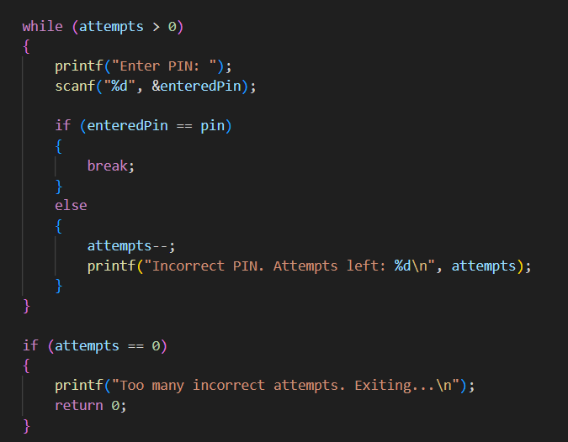

* A while loop runs as long as attempts is greater than 0.
* The user is prompted to enter a PIN, which is compared to the correct PIN
* If correct, the loop breaks; if incorrect, attempts decrease, and the remaining attempts
* If attempts reaches 0, the program exits with an error message.

**4.3. Menu and Transaction Logic :**

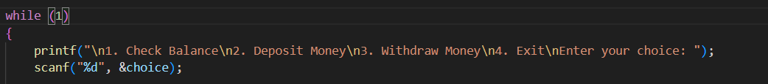

* An infinite While loop displays a menu and takes the user’s choice.
* The program uses an if – else structure to handle the four options.
  + 1. **Check Balance –**

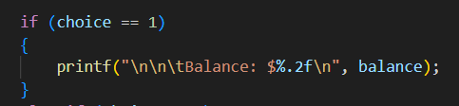

* Displays the current balance with two decimal places.

**4.3.2. deposit money –**

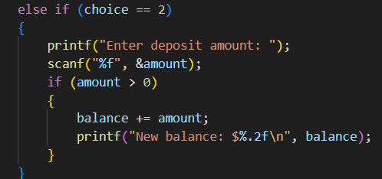

* Prompts for a deposit amount and adds Balance if the amount is positive.

**4.4.3. Withdraw Money –**

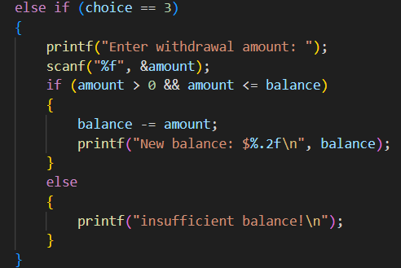

* Prompts for a withdrawal amount and subtracts it from balance if the amount is positive and does not exceed the balance. Otherwise, it displays an error.

**4.3.4. Exit –**

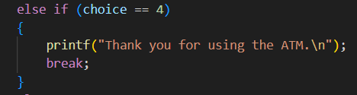

* Exits the loop and ends the program with a farewell message.

**4.3.5. Invalid choice –**

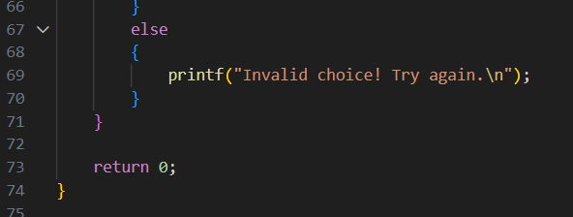

* Handles invalid menu inputs and here our program ends.

**5. Sample Output :**

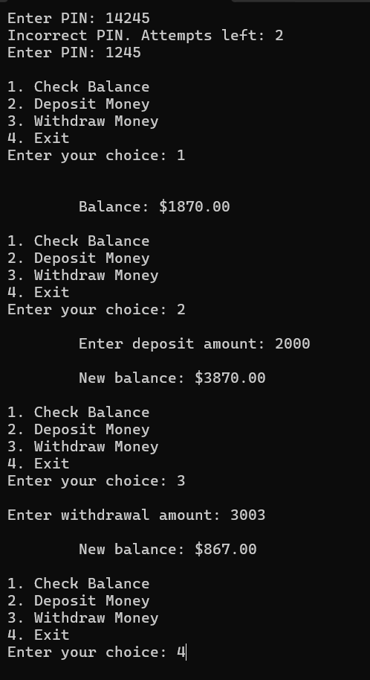

**5.1. Code :**

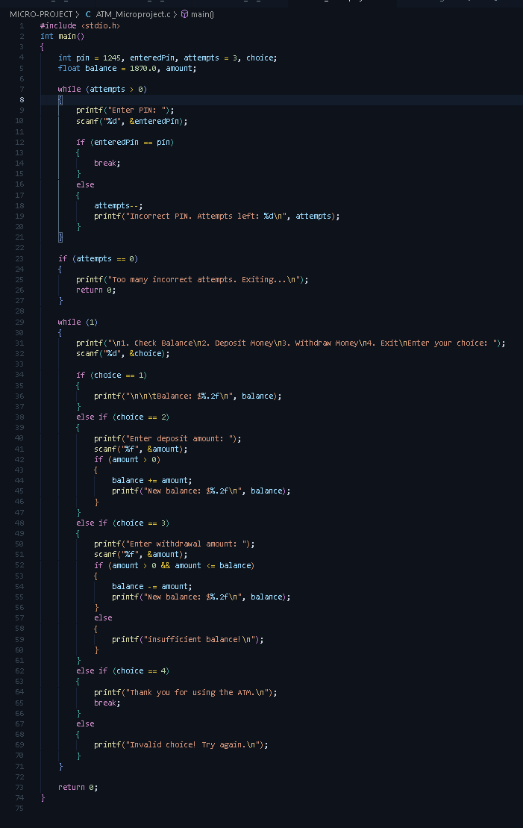

**6. Conclusion :**

The ATM Simulator project, developed in the C programming language, effectively replicates the core functionalities of an Automated Teller Machine, providing a simplified yet practical banking experience. **The program successfully implements** **a secure PIN verification system, limiting users to three attempts to enter the correct PIN (1245)** before locking them out, followed by a menu-driven interface that supports checking the initial balance of **$1870.00**, depositing funds, withdrawing money, and exiting the system. These features fulfill the project’s aim of simulating real-world ATM operations while maintaining user-friendliness and operational integrity.

In summary, the ATM Simulator stands as a successful endeavor that bridges theoretical programming knowledge with practical application. It delivers a secure, functional, and educational tool that meets its goals while remaining simple enough for beginners to understand and adapt. This project not only showcases the power of C in creating real-world simulations but also sets the stage for further development, proving its worth as both a completed task and a stepping stone for future learning.

* **Actual Resources Used**

|  |  |  |
| --- | --- | --- |
| **Sr.no** | **Name of Resource** | **Quantity** |
| **1.** | Laptop | 02 |
| **2.** | VS Code | 01 |
| **3.** | Microsoft Word 2021 | 01 |
| **4.** | Microsoft PowerPoint 2021 | 01 |

**References:**

1. <https://x.ai/news/grok-3>
2. <https://github.com/>
3. <https://codepen.io/>
4. <https://www.hackerrank.com/>

**Thank you…..**